RCS NEWSLETTER
January 29, 2021

Dear Richmond Consolidated School Families,

The current cold snap that started today reminded me of the opening stanza of Christina Rossetti’s, In the Bleak Midwinter.

In the bleak midwinter, frosty wind made moan,
Earth stood hard as iron, water like a stone;
Snow had fallen, snow on snow, snow on snow,
In the bleak midwinter, long ago.

I hope you stay warm this weekend as the Polar Vortex bears down on the Berkshires. Richmond Consolidated School is looking forward to the first week of February and our march toward the first day of spring.

Sincerely,

Rob Putnam

UPDATES

- The CDC recently released a study on school reopening during the Covid pandemic. Data from K-12 schools that reopened for in-person instruction in the fall show little evidence that schools contribute meaningfully to the spread of COVID-19. This report is consistent with our experience. RCS has been in the vanguard which is a source of pride. You can review two articles on the report below.
  - https://nymag.com/intelligencer/2021/01/cdc-studies-recommend-opening-schools-closing-indoor-dining.html
  - https://www.npr.org/2021/01/26/960885936/cdc-makes-case-for-school-reopening
- Winners of the RCS Punderland Contest are copied below.
- The minutes from the 1/20/21 PTA meeting are copied below.
- Ronna Zigmand will be the Yearbook advisor again this year and the Grade 8 students will be learning how to use the Yearbook website to help her create the yearbook. We have met with our Josten Yearbook representative, Mike Lenfest, virtually and he walked the students through the basics of using the software. During in-school and remote Technology classes I will be working with the students to create this year's unique yearbook. Each Grade 8 student will have a full page in the yearbook to commemorate their time at RCS. Please work with your student to come up with pictures that you would like used on this one page spread. These can be sent to me directly via email or they can be submitted directly to the yearbook website following the directions below in the attached flyer from Jostens.
- Thanks to generous funding from the PTA, Mrs. Kanz hosted- via Google Meet- author Kristen Levine on Thursday, 1/28. She met with the 6h graders to talk about the history behind her novel, “The Lions of Little Rock.” She also met with the 8th grade to talk about her experience doing historical research and she will provide background on desegregation. The 8th grades are reading Warriors Don't Cry so this is a perfect curriculum connection.

RCS Winter Punderland Contest Winners
Punniest Funniest Pun: William R. | “Stop! You’re under a rest!” 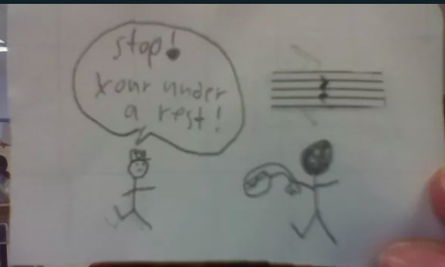
Most Creatively Presented Pun: Liam L. | 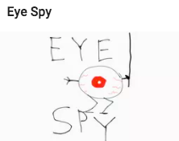
Most Original Pun: Annie F. | 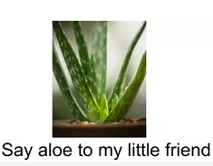
Best All-Around: Sofia H. | 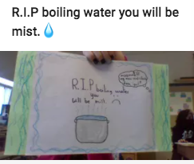
Honorable Mention: Bella D.
Link to the rest!

